Sep22 - 27

18.00 - 20.00

Recommendation system workshop

by

<https://www.linkedin.com/school/management-career-institute/>

search management career institute at fb

<https://www.linkedin.com/in/kunal-soni/>

queries - +91-9977220325

website links

<https://managementcareerinstitute.bitrix24.site/>

zoom :

<https://us02web.zoom.us/j/86707922764?pwd=bGp3NlZUUzJDbFhObzRIY09aWFFWQT09>

WhatsApp group:

<https://chat.whatsapp.com/BiEMzB0Bc4GG3WNhjARTBY>

day1 colab:

<https://colab.research.google.com/drive/1nGrprmwEJ9m1YSxPf4kO4ztkcLrDKjci?usp=sharing>

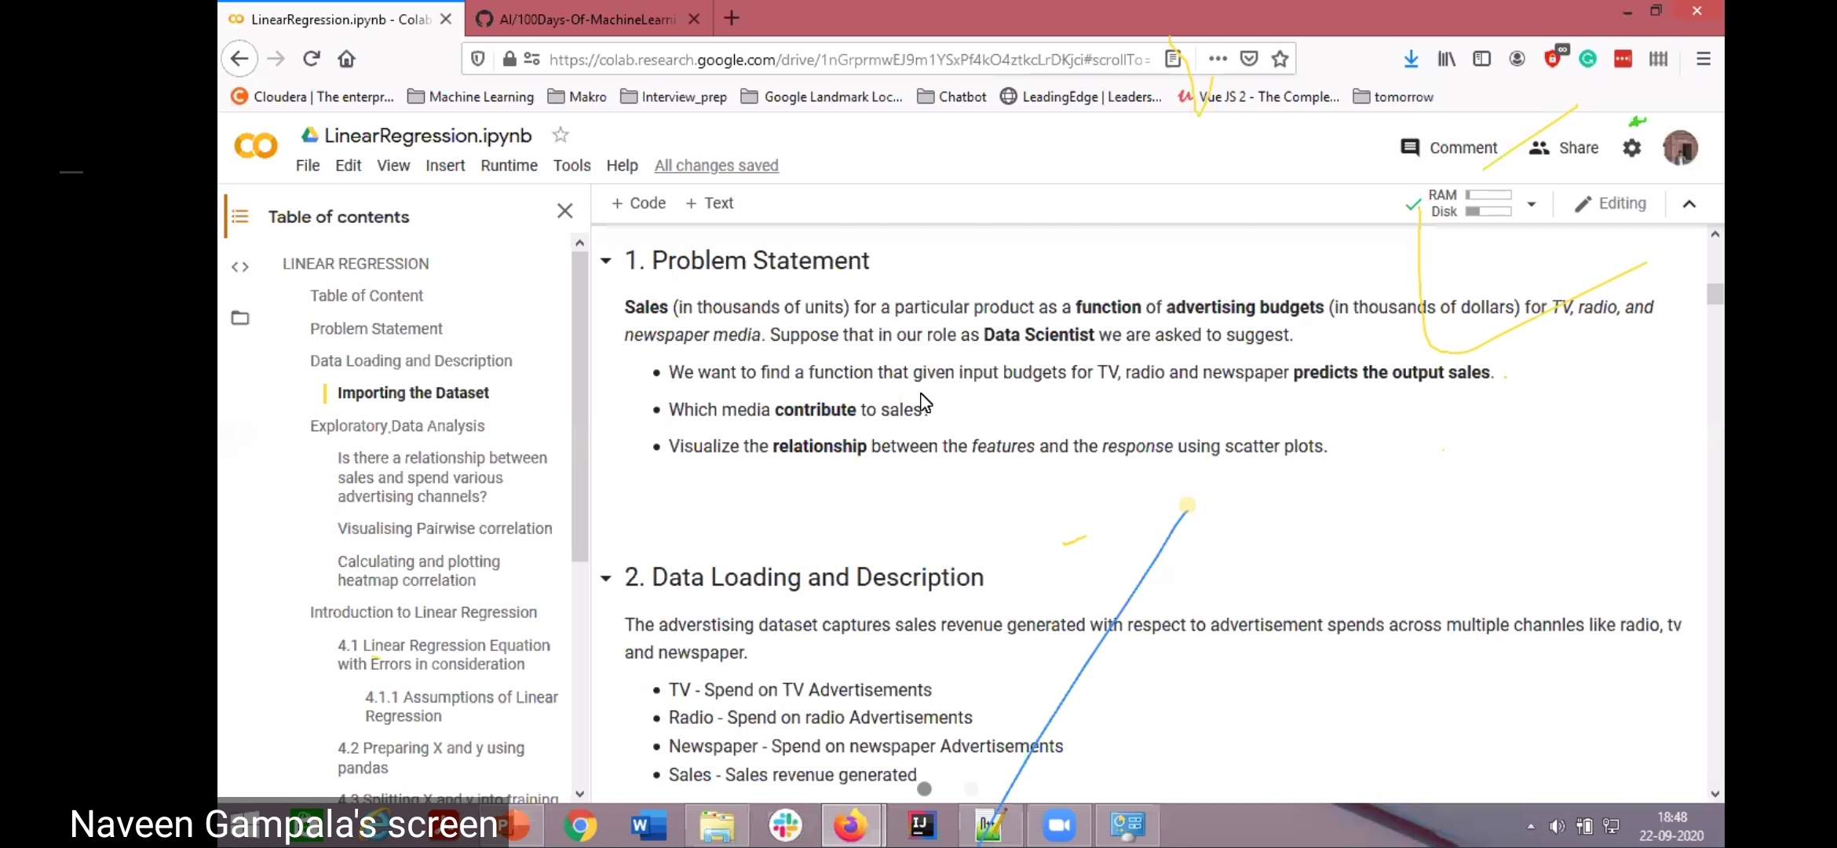

GitHub link:

<https://github.com/naveengampala/AI/tree/master/100Days-Of-MachineLearning/data>

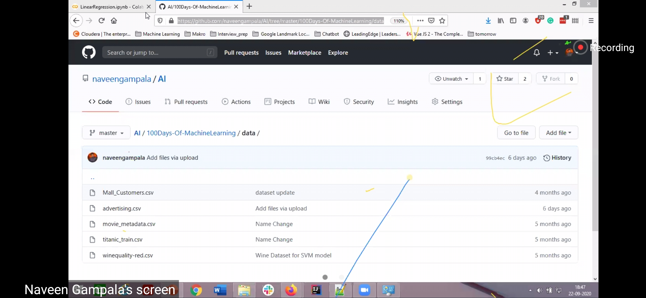

1. Module 1: Fundamentals of Data Science (3Hours)

● What really is data science told by DataScientist

● Intro to Data Science

2. Module 2: Exploratory Data Analysis with Python (2hours)

○ EDA; Titanic Dataset

3. Module 3: Supervised Learning Algorithm (2 Hours)

○ Linear Regression Case Study

○ Logistic Regression Case Study

4. Module 4: Unsupervised Learning Algorithm (2 Hours)

○ KNN Case Study

5. Module 5: Product recommendation with Machine Learning (2Hours)

○ Product Bought Together Case Study

○ Product View Together Case Study

6. Module 6: Deep Learning Algorithms (3.5 Hours)

○ Neural Networks (CNN, RNN)

7. Module 7. Product Recommendation with Deep Learning (4 Hours)

○ Advanced Product Bought Together

○ Advanced Product View Together

8. Module 8: Sequential Product Recommendations (4 Hours)

○ Session Based Sequential Recommendation Engine

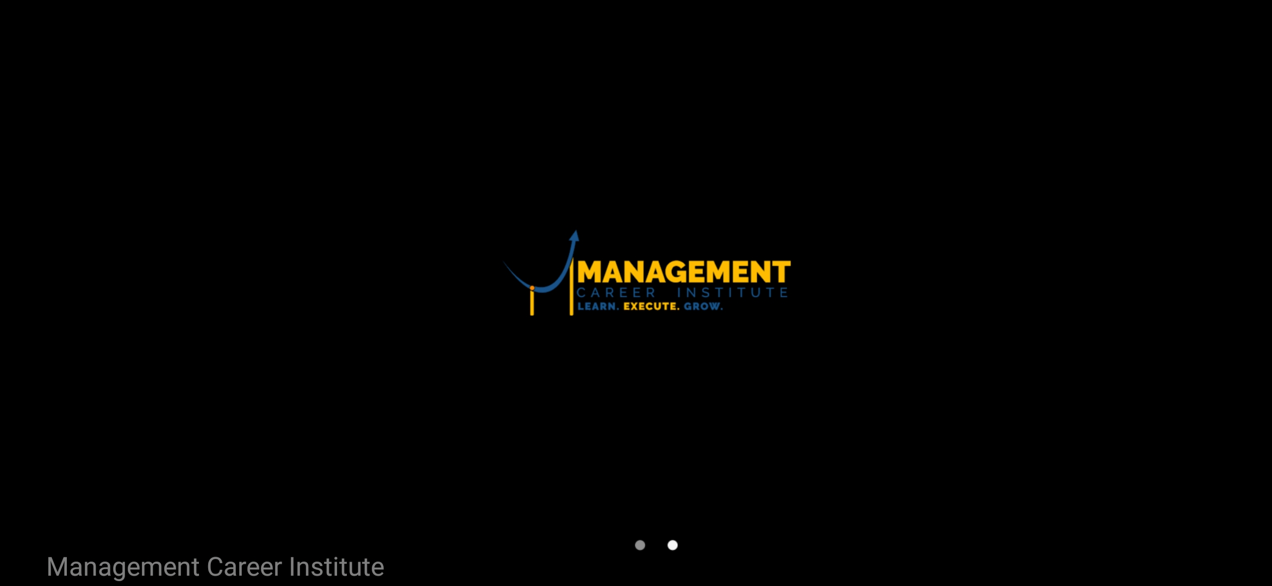

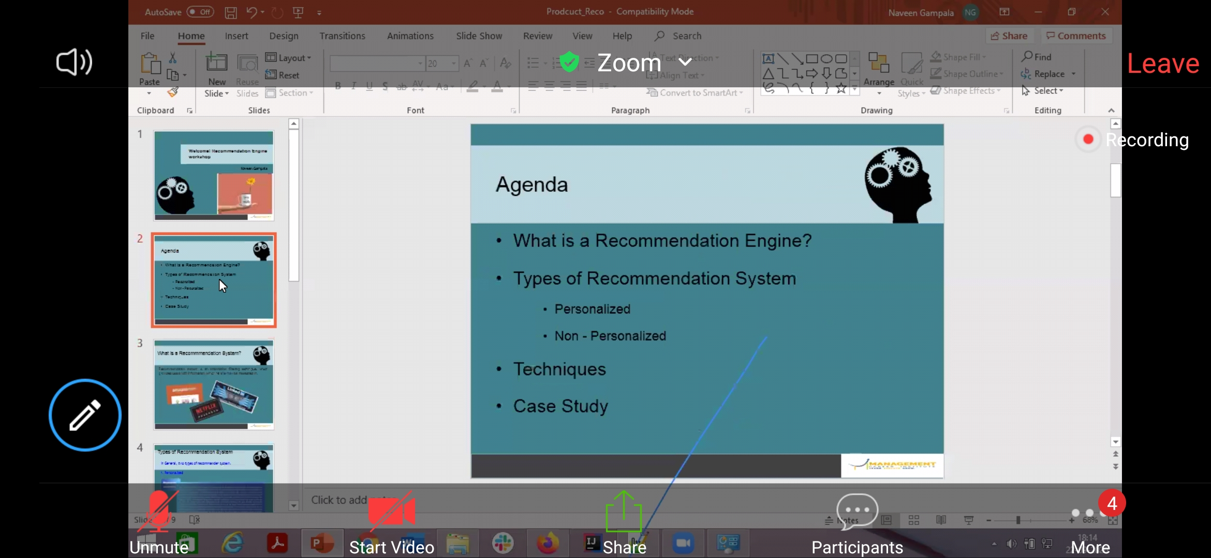



* automatically recommend products based on your preferences
* recommendation system - suggestion or recommendation according to our porevious preferences choices and activities

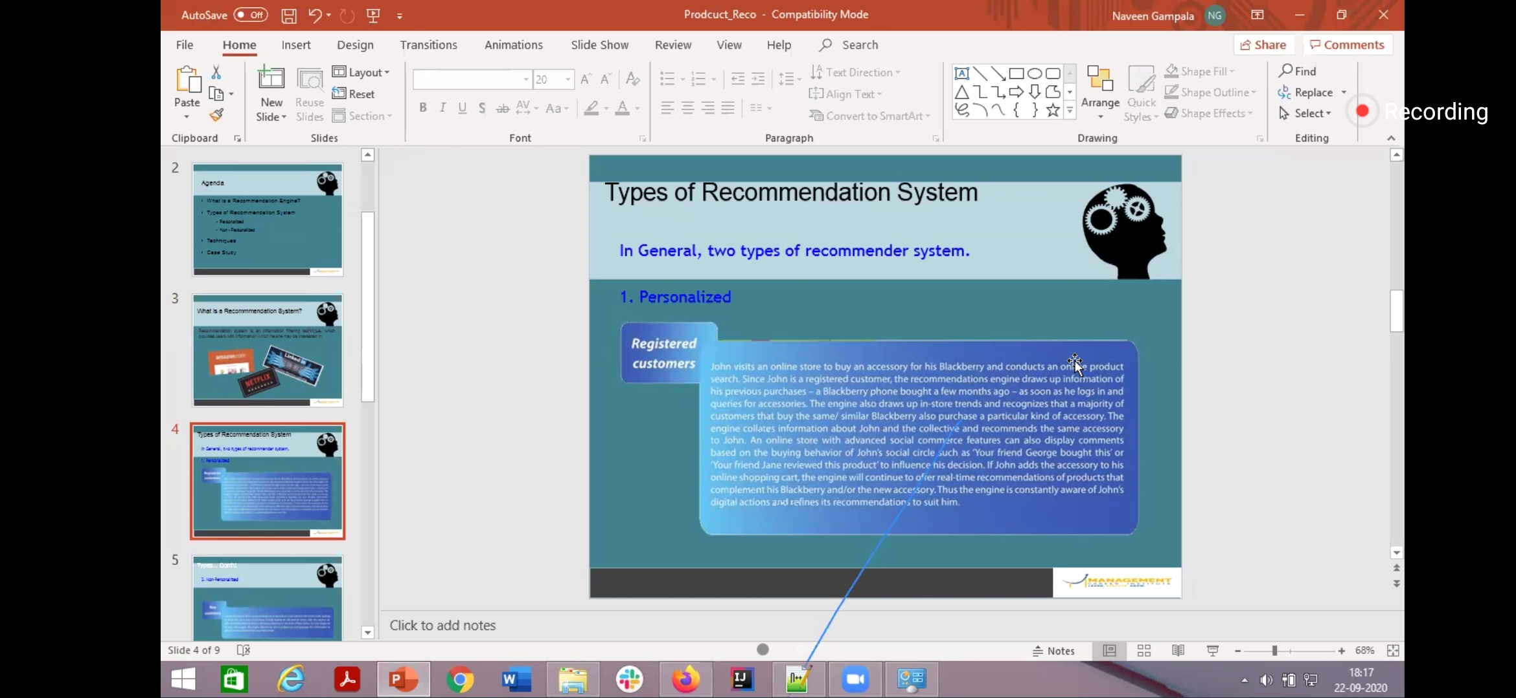

* we know info about registered people , so we use ML models & recommend products .. customer relationship with products can be done or different best recommendations ..

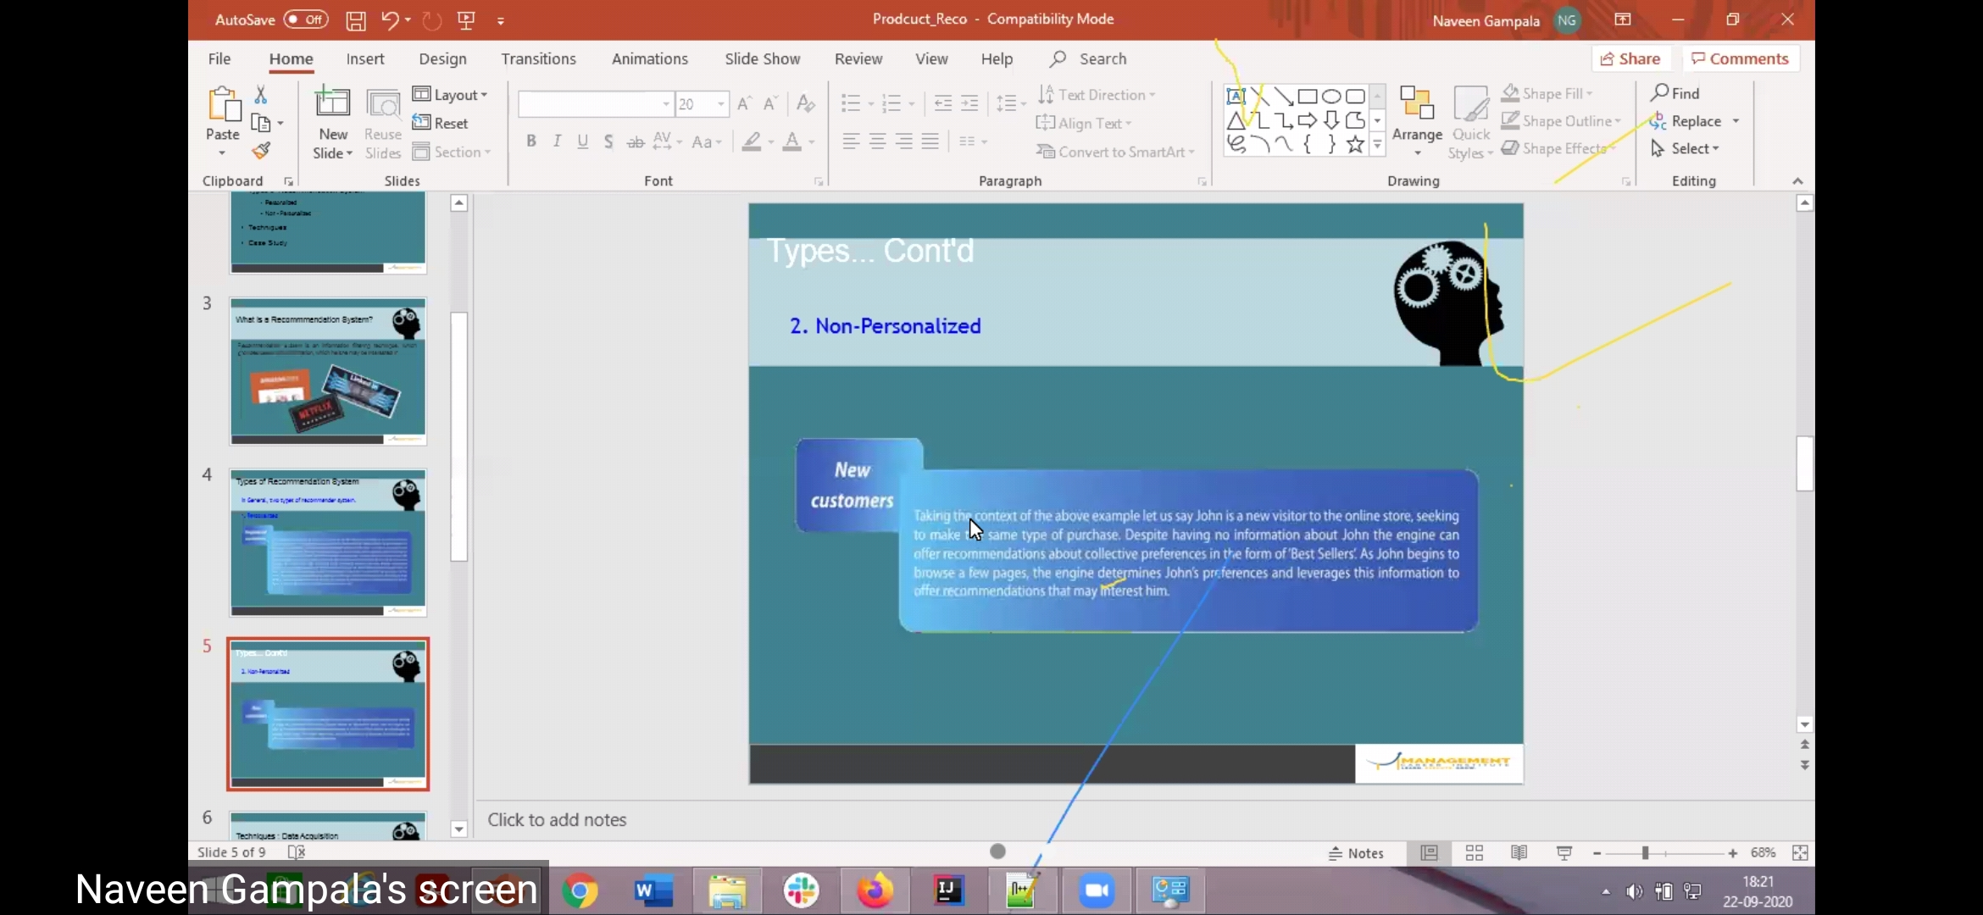

* if new customer , we don't know about the user , but we know something about the product ge searching .. so relationships among products is know , it helps in recommendation system ...

Hybrid model - both personalised & non personalized ..

Techniques:

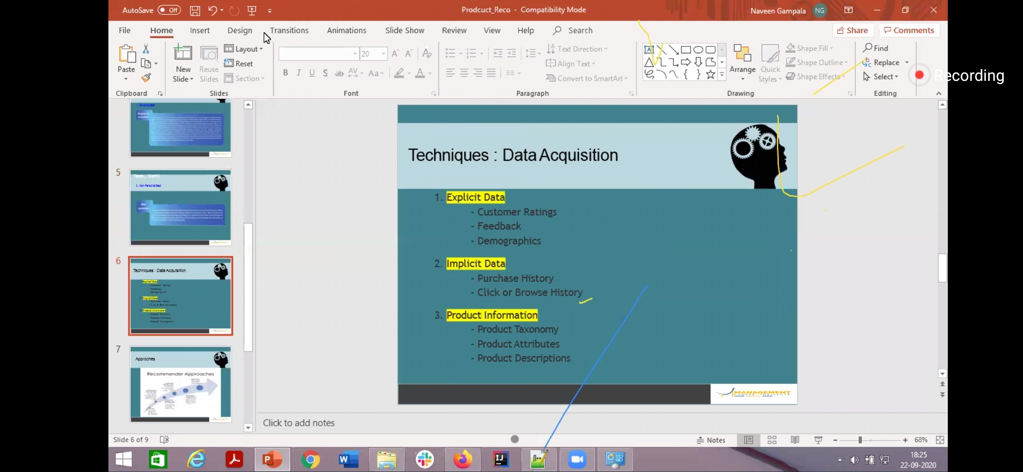

* fact : Amazon recommendation is changes from day to night too ..

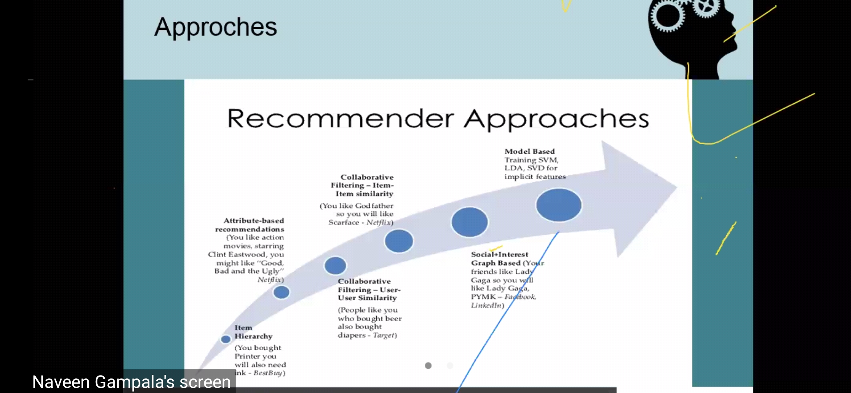

* we make relationship matrix between things & refer to it whenever needed ..

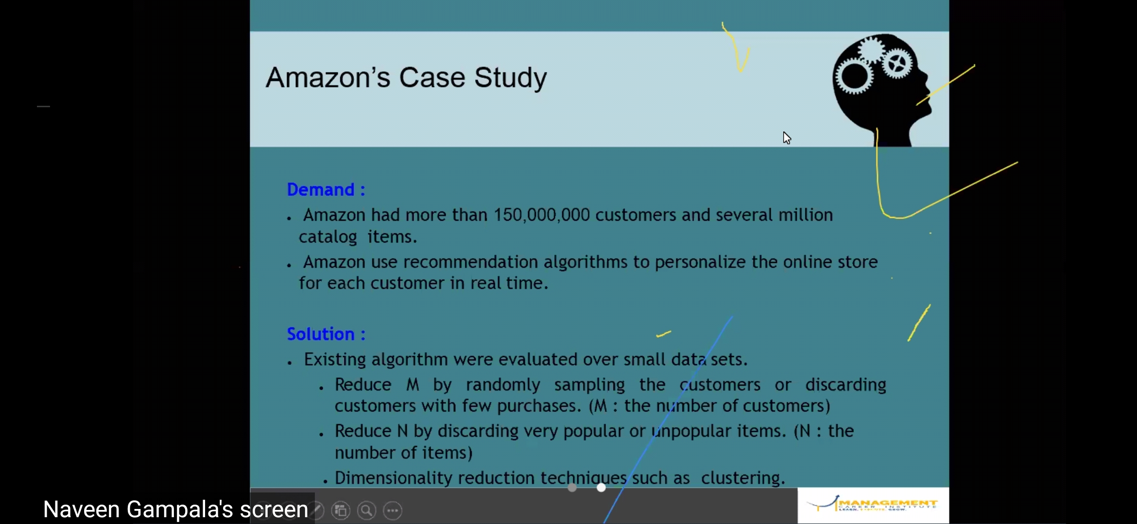

its amazing how exactly amazon doing personalized for those 5 crores customers ..

\*35 percent extra selling increased because recommendation of amazon

First company do recommendation is Netflix ...

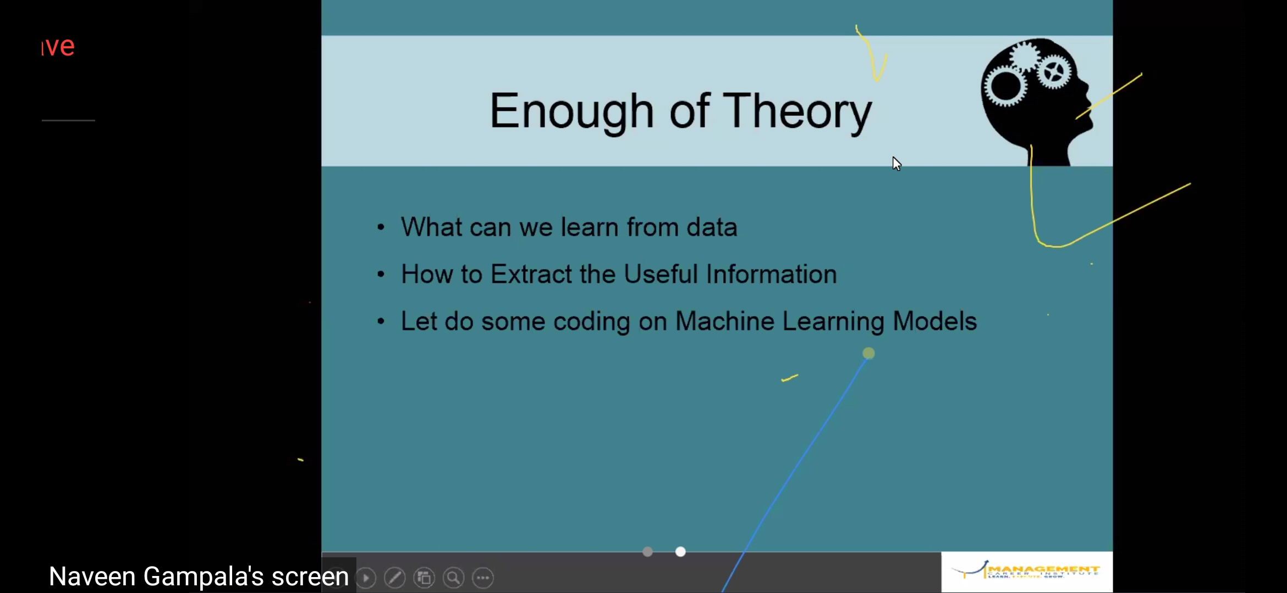

* COLAB GOOGLE - 130gb ROM for one colab user .. with 12gb ram ..

Problem statement :

3 products - TV , Radio , Newspapers - which contribute more for company ?

* most important thing in ML is data reading …

{

shared :

<https://github.com/firmai/business-machine-learning/blob/master/README.md>

}

learn in kaggle… money prize contest

<https://www.kaggle.com/notebooks>

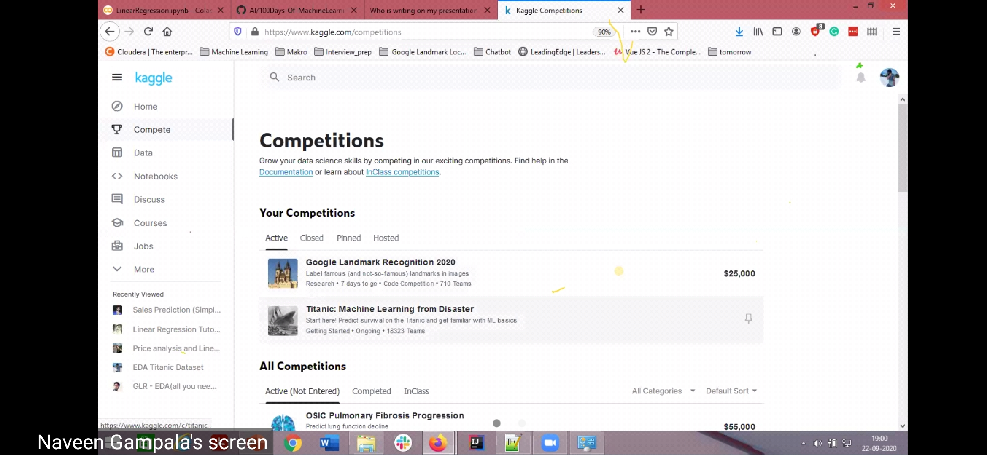

data.head(6)

* head() - first rows
* tail() - last rows
* iloc() - particular location

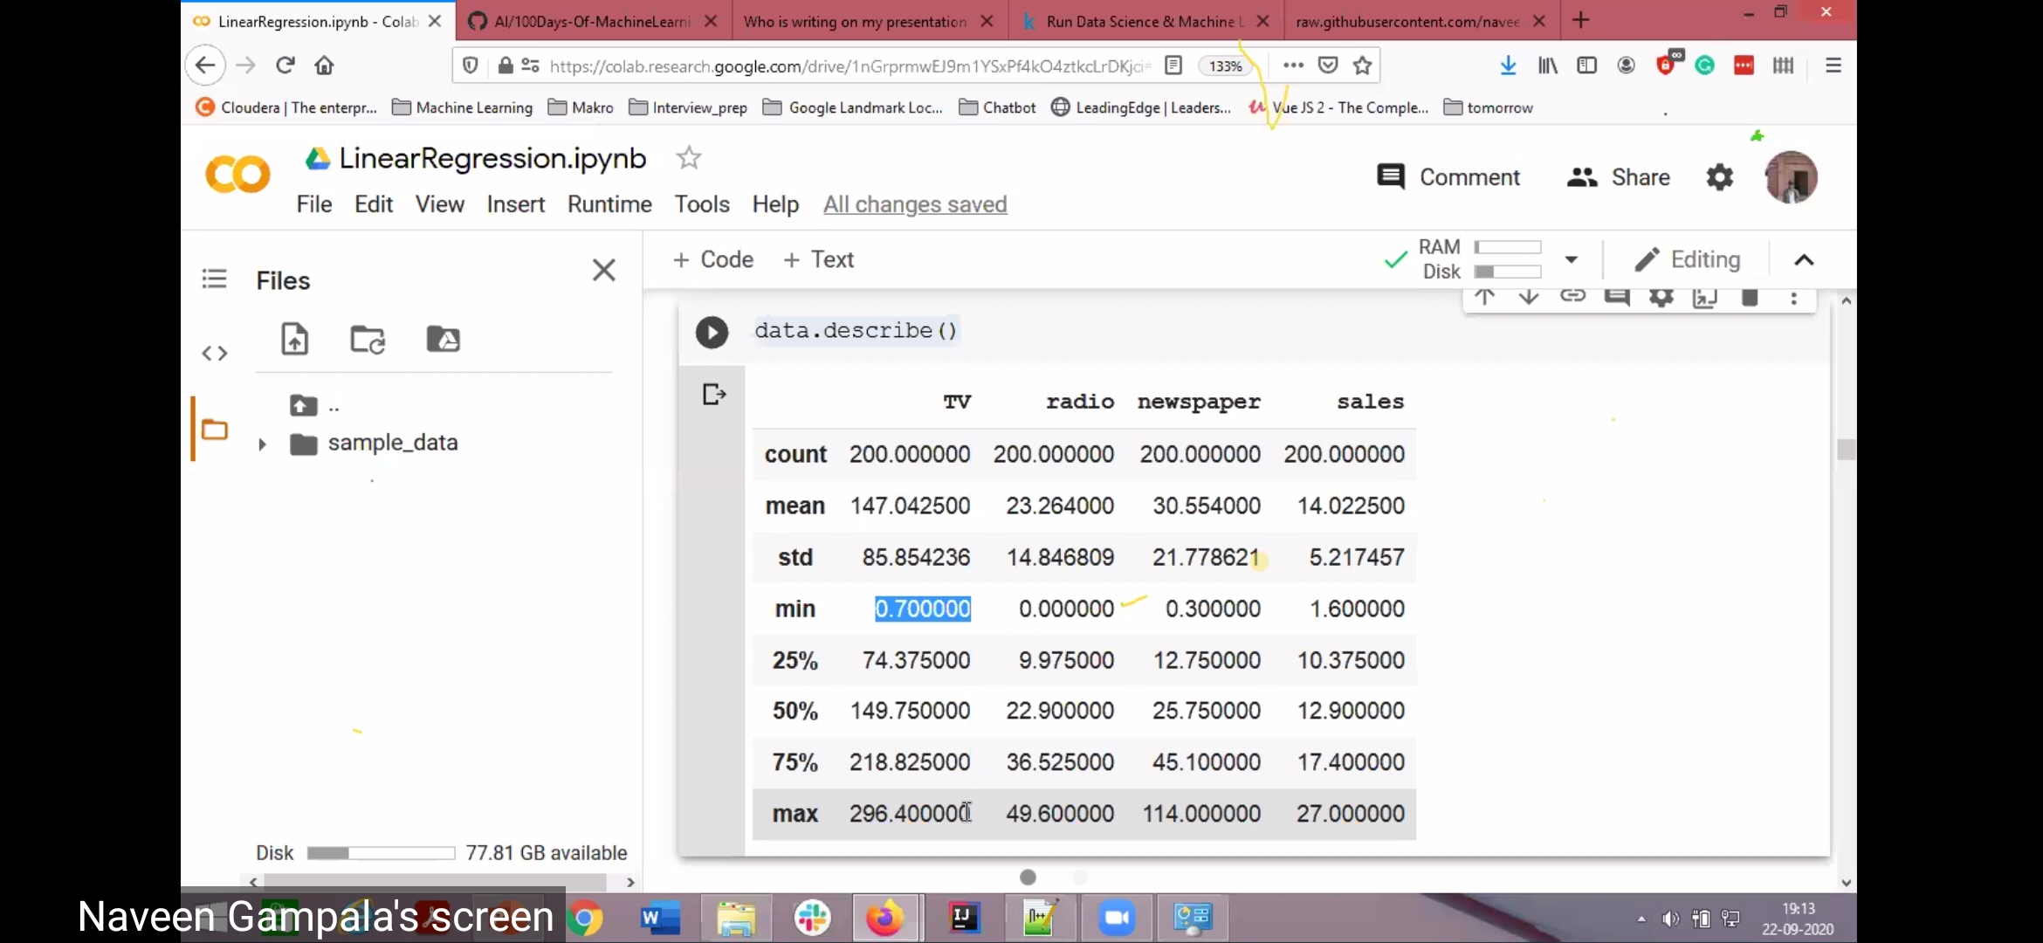

assignment:

1 go to GitHub link.. copy raw data link & paste in code…

2